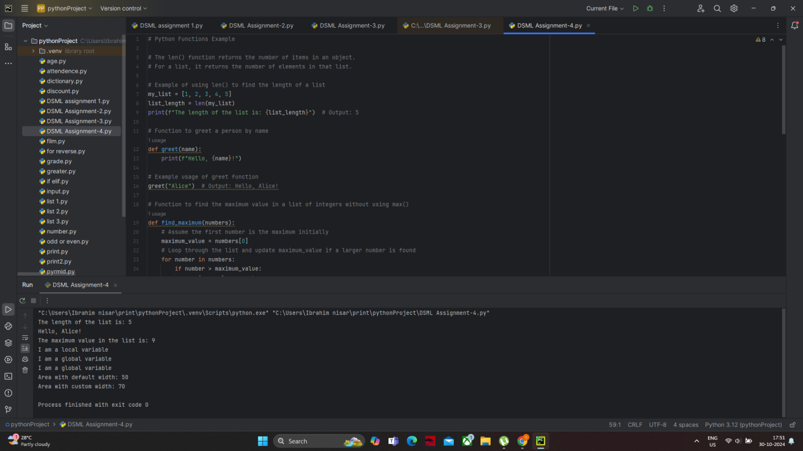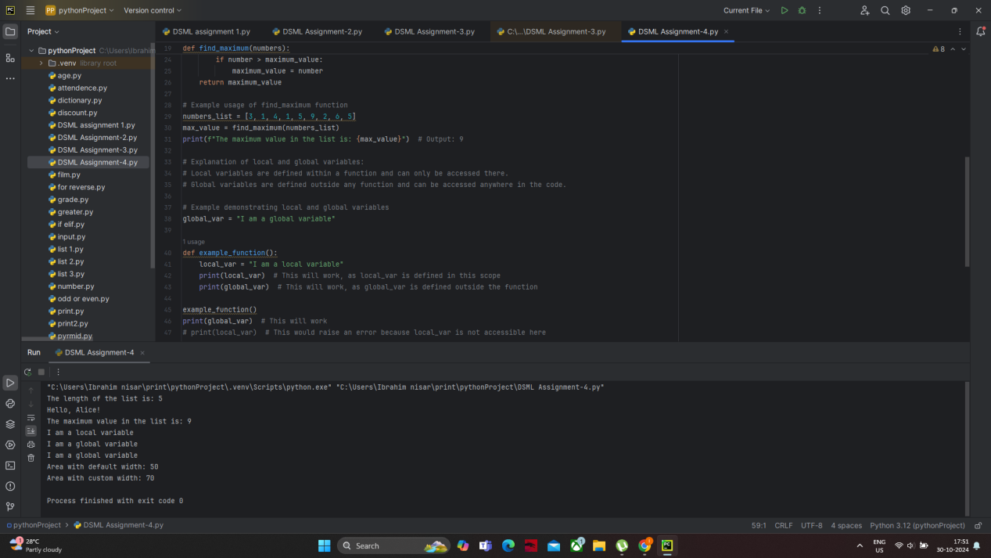

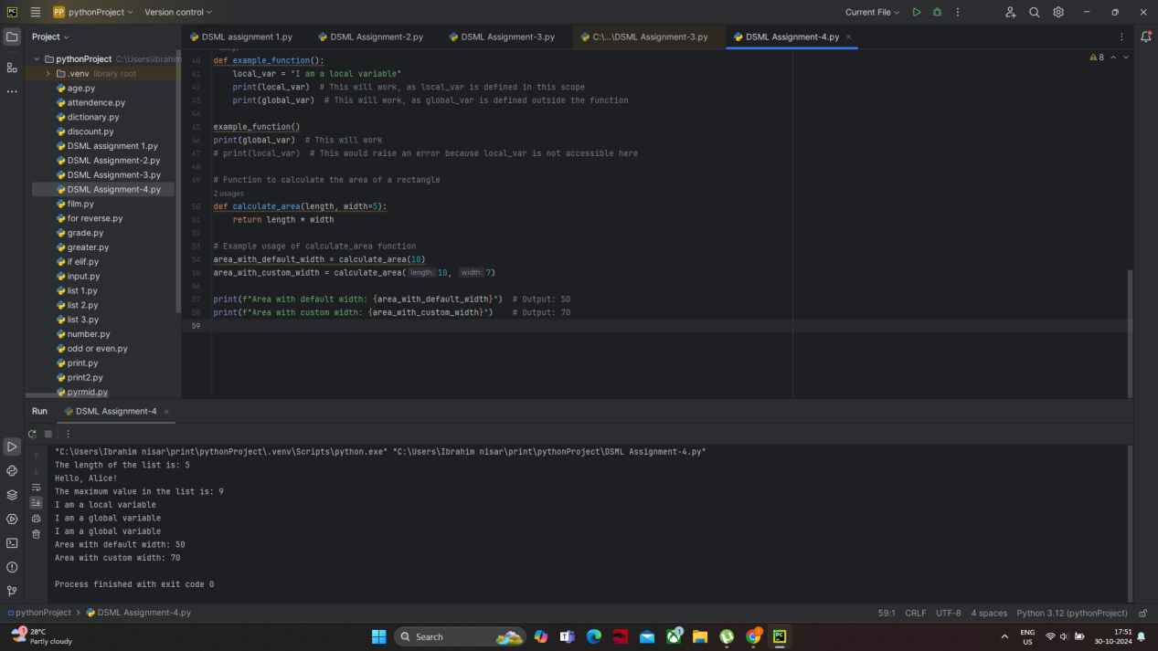

1.**len() Function**:

The len() function counts the number of items in an iterable (like lists, tuples, strings).

2.**Global vs. Local Variables**:

**Local Variables**: Defined inside a function. They exist only within that function's scope and cannot be accessed from outside.

**Global Variables**: Defined outside of any function. They can be accessed from anywhere in the script.

3.**Function Behavior**:

The calculate_area function demonstrates default parameters. If only the length is given, the width defaults to 5.